Haite and Carlos

Great intro!

Good job with agenda… animated bullet points will help here.

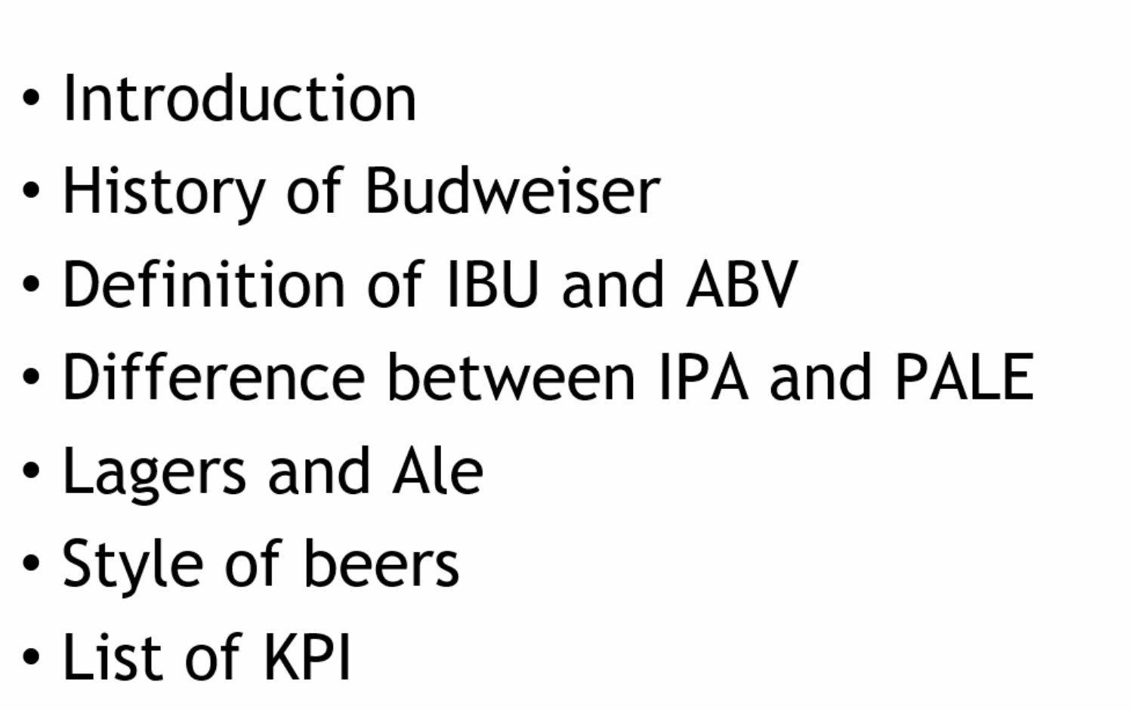

Same here…. You might try and summarize these into smaller bullet points. I got a bit lost trying to read this and listen at the same time.

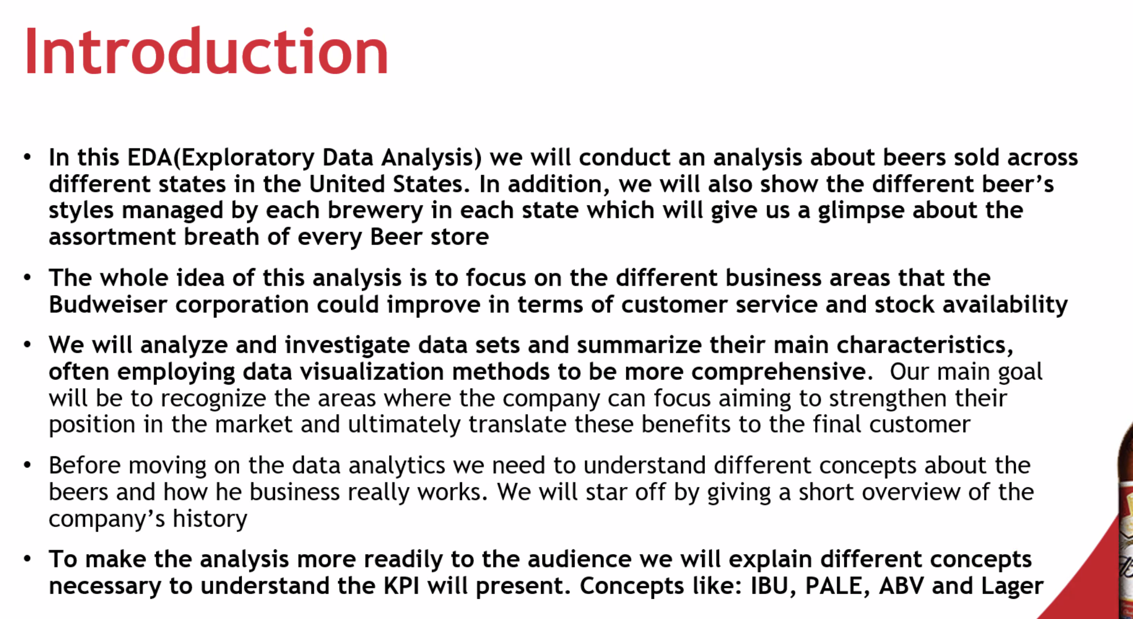

Keep practicing to make it smooth.

Beautiful slide .. lots of words though.. same attention issue.

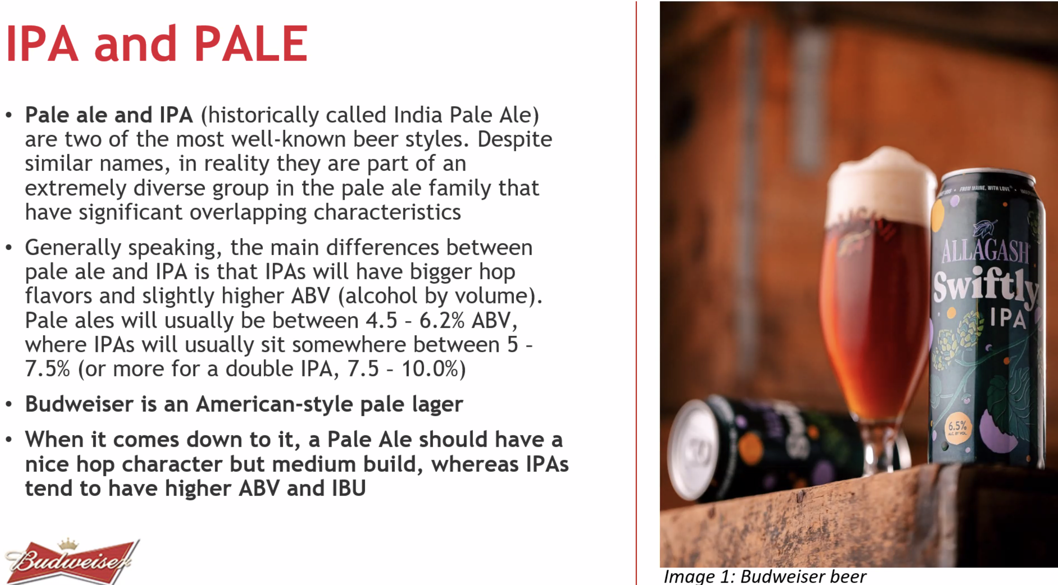

AWESOME!

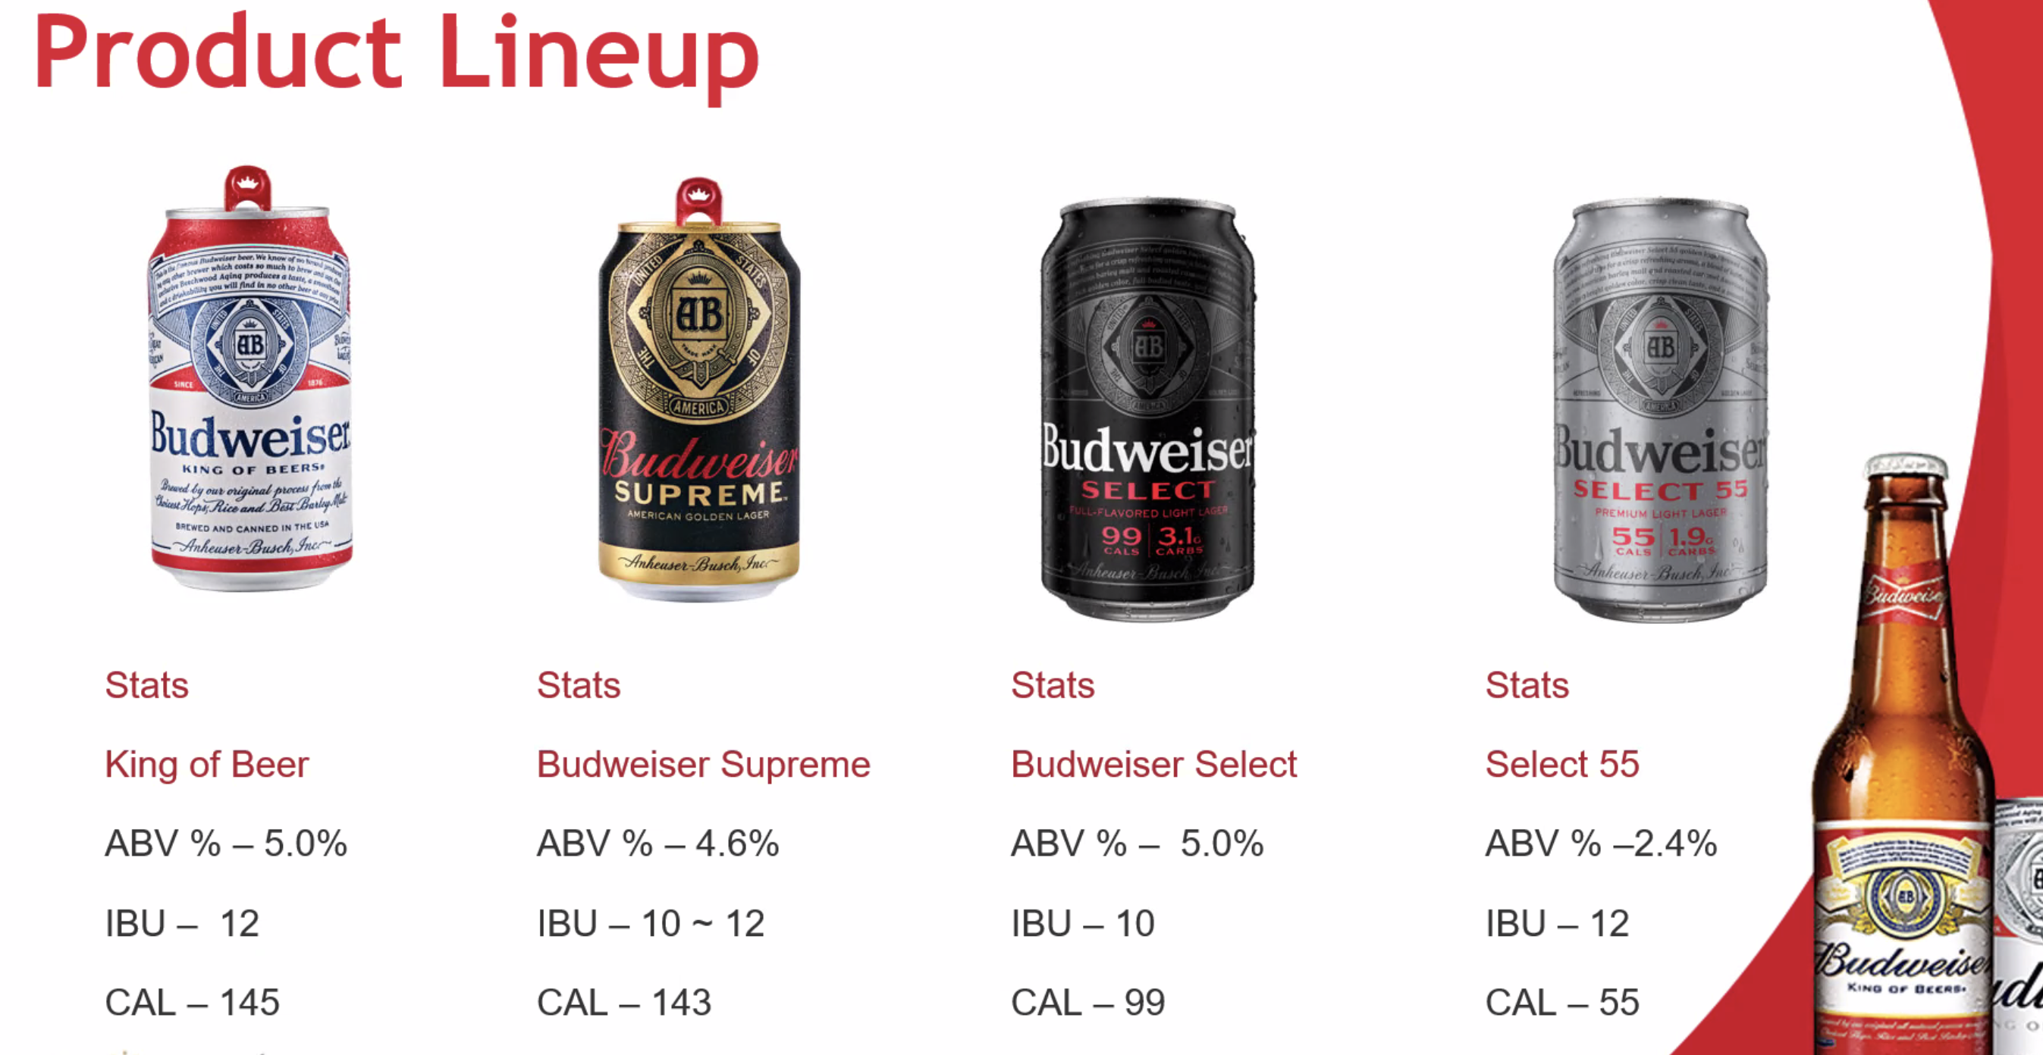

Just more practice will make things smoother… when you are rolling .. it sounds great.

Staring reading on this slide… make these bullet points and talk to audience rather than reading off the slide. I think I like the live highlighting … but don’t get too busy with the cursor.

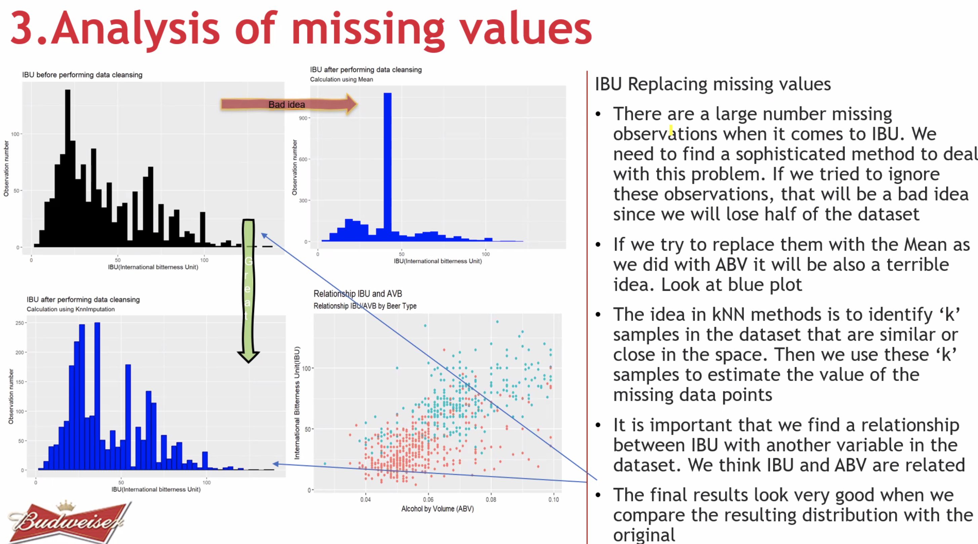

I would not include the code.. it is cool … but not helpful to the CEO.

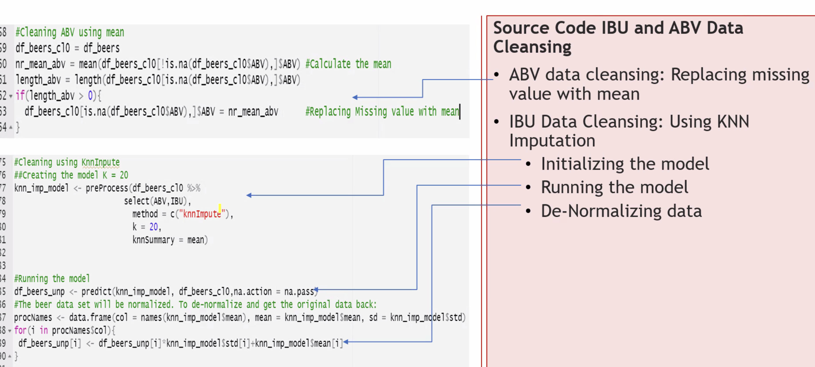

Need to think about time.

Good idea to market differently to Texas… maybe back that up with more evidence (data).

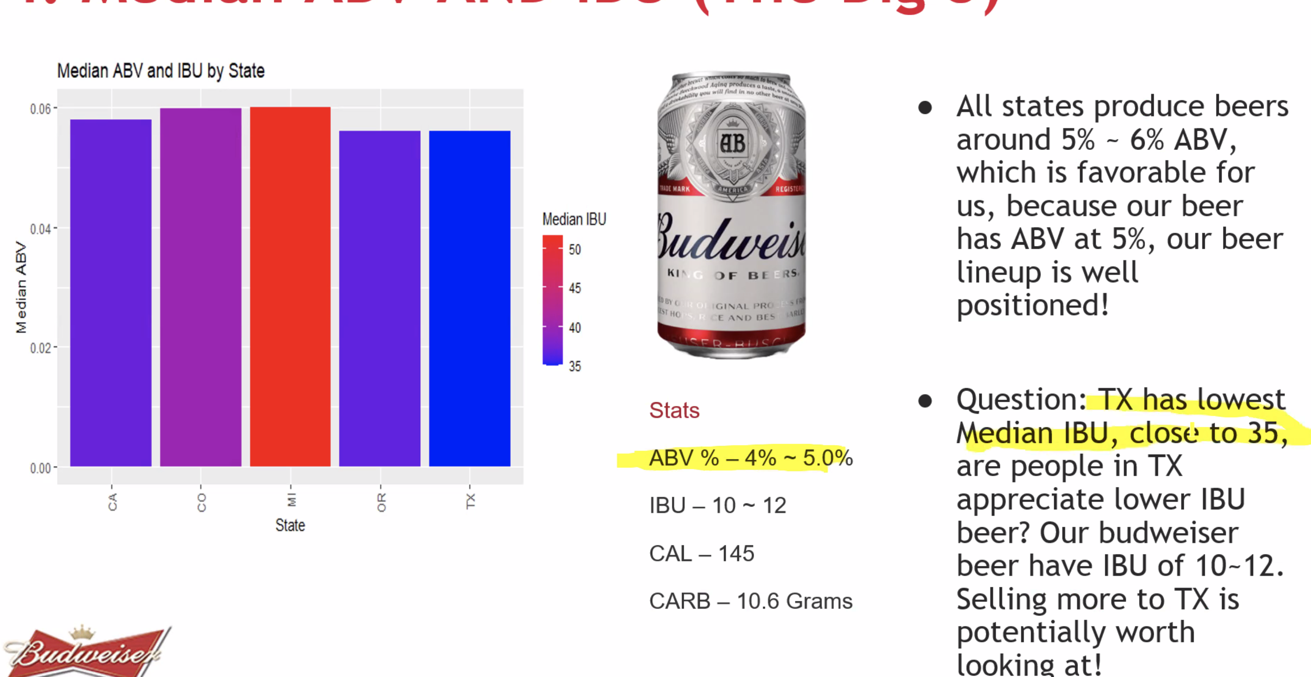

You all have great slide design.. there are too many slides… but each is really nicely designed.

Note that as “ABV increases so does IBU” … not true… an increase in ABV is associated with an increase in IBU.

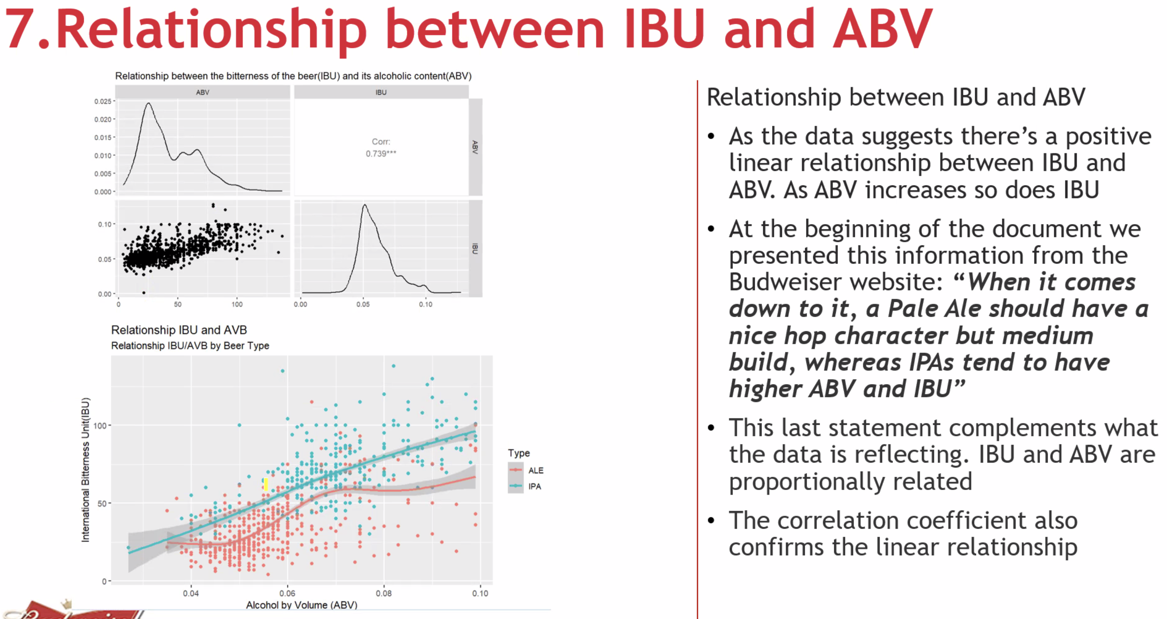

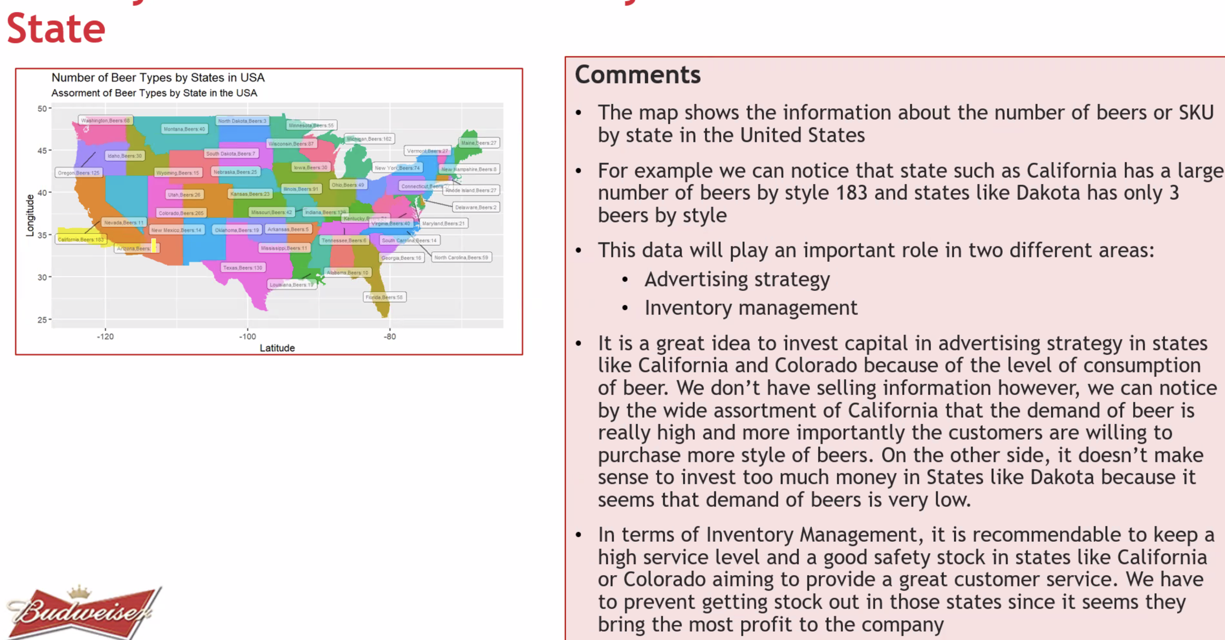

Loved the business insight here:

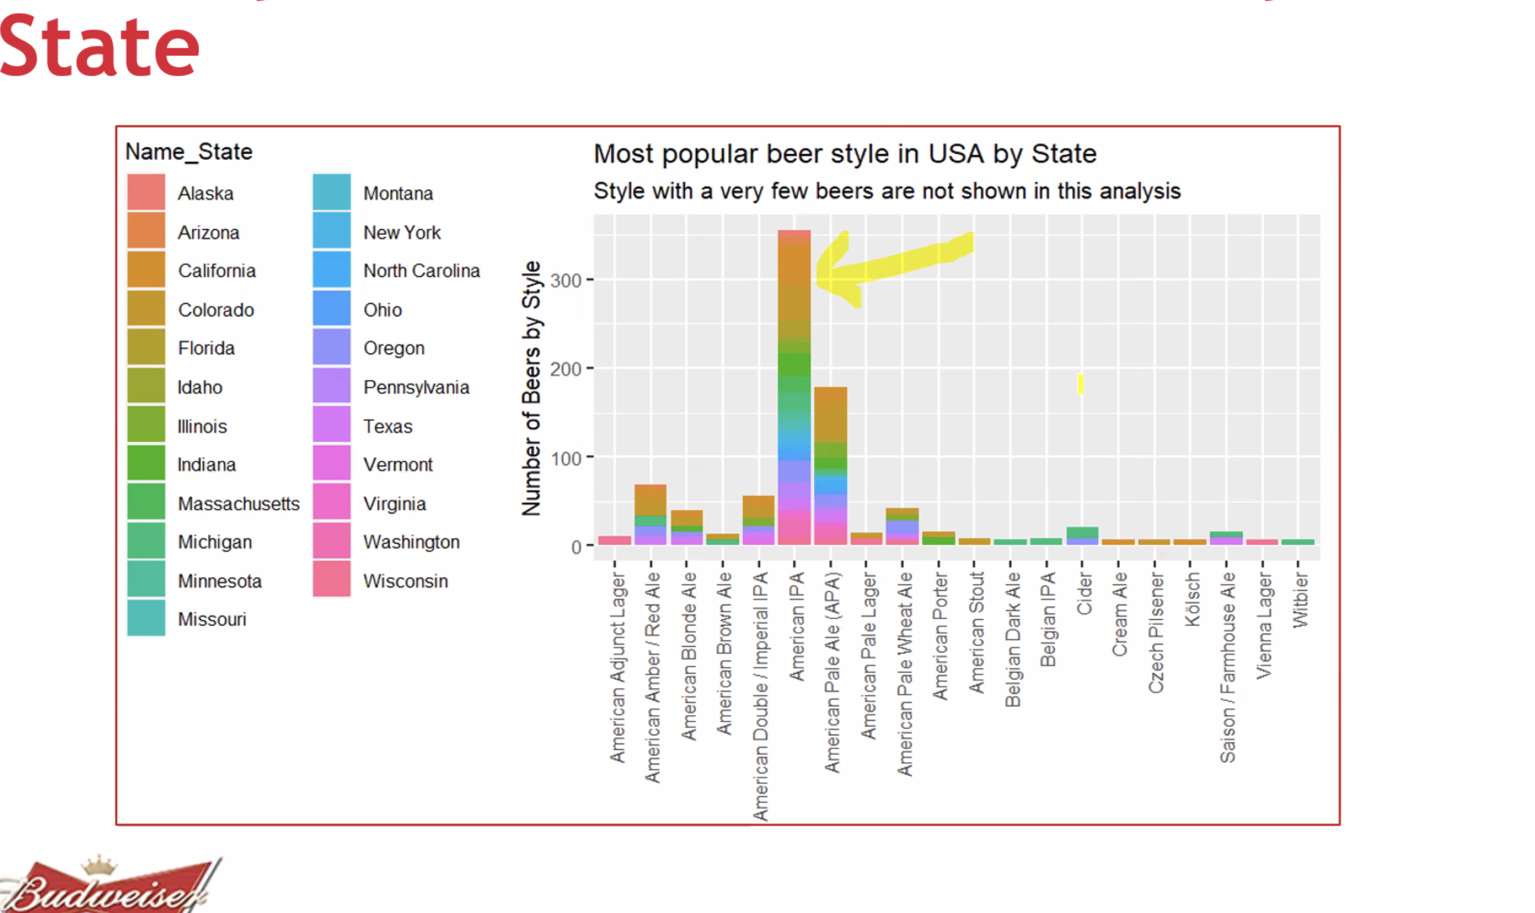

Great conclusion.. mention names and emails.